INPI
SERVICES & BENEFITS
Detailed Functional Specifications

Contents
Notes
CMS administration
Language
GUI management
SKU
SIZE IMAGE
CROSS ELEMENTS
Information Architecture
descent Navigation
TYPE 1 - CLASSIC
TYPE 2 - SPECIAL
Schematic picture of the architecture of the Boutique
Content Store
HOME PAGE - FACILITIES
Wireframe
contents
LIST PAGE
Wireframe
B. Contents
DATASHEET: ALL TYPES
Wireframe
contents
DATASHEET: ENQUIRY
wireframes
CONTENT
PAGE CART
WIFRAMES
CONTENT
REGISTRATION PAGE
A. Wireframe
B. Contents
MY PAGE CONTROL
A. Wireframe
B. Contents
PAGE PAYMENT
HOME PAGE PAYMENT ACCOUNT INPI
HOME PAGE PAYMENT ACCOUNT CB Paybox
HOME MY PROFILE PAGE
WIREFRAME
BEHAVIOR
MY PROFILE PAGE - ORDER DETAILS
WIREFRAME
BEHAVIOR
BACK-OFFICE
TABLE OF MANAGEMENT - N0 - VIEW OF ORDERS
TABLE OF MANAGEMENT - N-1 - PRODUCT VIEW
TABLE OF MANAGEMENT - N-1 - VIEW OF ESTIMATE

lack:
Doc tech for the week of 27/06?
- The course of payment and technical information to check the understanding of the needs and constraints INPI (MAJ price fields necessary for collection, ...
- Management of the following price display if they come from cashing or a price "com"
- Management flagship products rise in BO
- Cashing Management
- Equivalence between data in drupal and cashing in
- The order number is an "integer" (order number with numbers). If a specific format to be expected, talk about it.
- Parameter management in BO
- Operation of the watches.

General:
non-editable content BO: to be defined in a content package. None of the texts contained in this doc or the models are validated to date.
UX: the built-UX screens in this document have been reduced to allow an overview. The UX full size is available online cf Annex UX.

NOTES

- CMS administration
In this document of functional specifications, Razorfish will make recommendations in terms of number of characters for the contributions of fields and the CMS label. Borne by the contributor to be vigilant that the seizure had no effect on the display of front pages.

- Language
INPI.FR The site aims to be in 2 languages: EN and FR. For category Services & Facilities site will be available in French. However, it has been designed to accommodate multilingual technical perspective.
. Any URL that will take the following formhttp://www.inpi.fr/en/urlservicesetprestations/ will be redirected to the URL of the item shop.

- GUI management
Setting a GUI: stratum associated with a content type that can be placed in several places in this type of content.
The GUI are associated with certain types of content the final SFD recasting INPI.FR

- SKU
Drupal Commerce, an SKU (Stock Keeping Unit) is the main identifier of a product.
It will set up three types of SKU: A SKU represents a type of sheet:
- Product SKU Paying
- Free Product SKU
- SKU quote
At each SKU will link a list of fields / parameters. The combination of the two will create a sheet.
SIZE IMAGE
sheet: 300px x 200px
Page List: 300px x 200px
Search Engine: 300px x 200px
PUSH APL
Push BureauPush TablettePush Mobile
370 x 230 300 x 187 270 x 168

- CROSS ELEMENTS
Here are the transverse elements set production INPI.FR:
- INPI.fr header (not that of the galactic inpi.fr)
- INPI.fr footer (not that of the galactic inpi.fr)
- push Services
- Sharing bar: Pin + Social Networks
- Link "load more" down lists
- Breadcrumb
- All GUI INPI.FR
- "Back" button on the top left of the page
- blue link "Read more»
- Push APL (Do More)
- Display and date format

Elements specific cross stores:
- Cover Image
- Shopping in the remote
- labels
- Filter management

PRODUCTION
- Information Architecture
The store will consist of a main HOMEPAGE (N0) with the following levels (N1), not definitive, to validate the happy pack:
- BASE WITH FREE
- CUSTOM RESEARCH
- HELP AND SUPPORT
- COPIES AND ENVELOPE
- TRAINING
- STUDIES AND RESOURCES
Please note, titles of those levels are not final, they will validate the document Content Pack.
From these 6 categories we will have two types of descent catalog.

1.1 - TYPE 1 - CLASSIC
Conventional scheme:
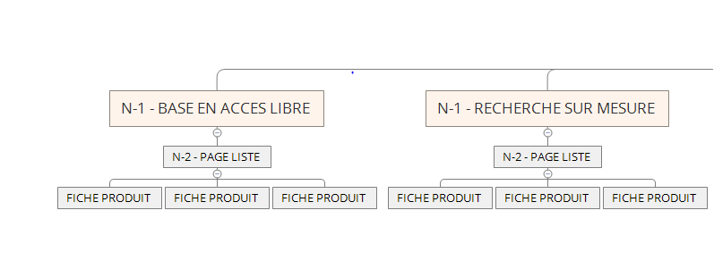
Here the type of descent catalog will include an N-2 level, access to the LIST PAGE with the following elements:
- DATASHEET 1
- DATASHEET 2
- PRODUCT DATA 3
- ETC ...

1.2 - TYPE 2 - SPECIAL
Schematic special type:
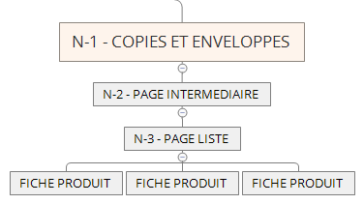

Here the type of descent will include an INTERMEDIATE LEVEL (N-2), between HOMEPAGE LIST PAGE and with the following:
- BY CATEGORY 1
- IN CLASS 2
- BY CATEGORY 3
- ETC
From these categories we will have N Following the descent catalog with access to the LIST PAGE (N-3) with the following:
- DATASHEET 1
- DATASHEET 2
- PRODUCT DATA 3
- ETC

Summary diagram of the two types of architecture:
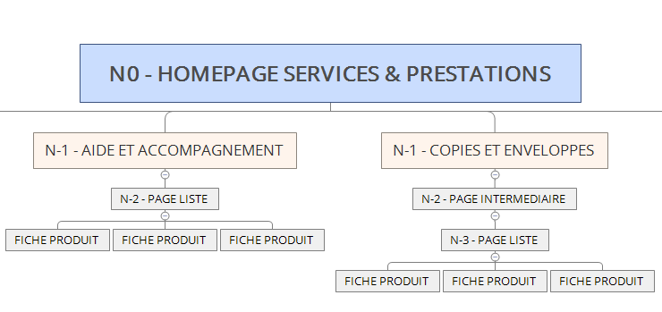

1.3 - Summary table of the architecture of the Boutique
Table ARBO S & P provides in Appendix reference is approved by the INPI for the operating principle of N (0) N (-2). N levels (-2) are not yet fixed or all the products indicated in the table.

CONTENTS OF THE SHOP

0 - GENERIC ELEMENTS
  - - Managing expand

Wireframe

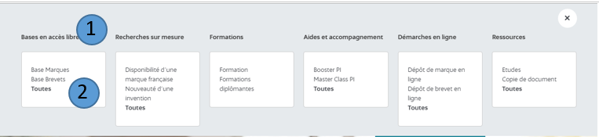

TABLET

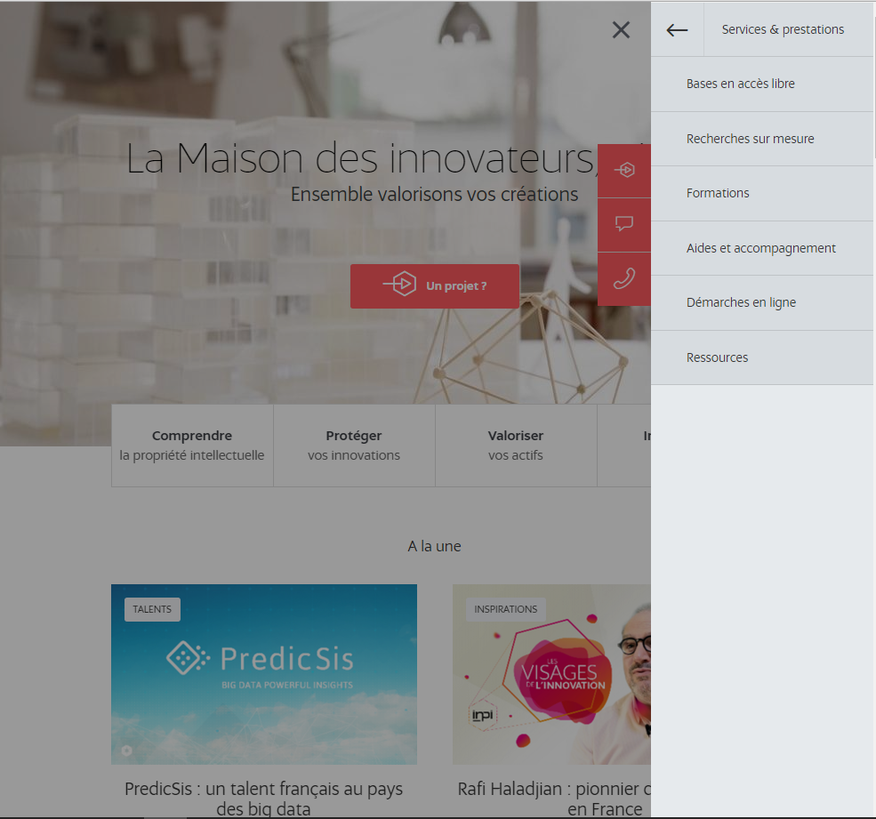

MOBILE

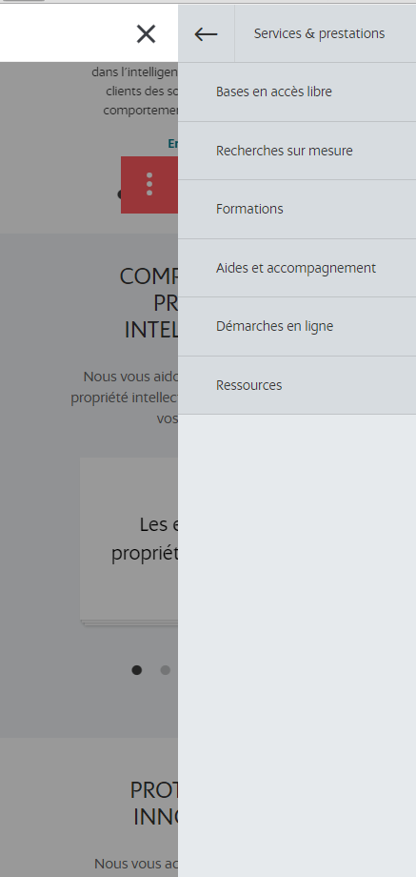

contents

ZONED | NAME | FORMAT | RULE MANAGEMENT
1 | Title Category | Text | RG1: Front-End Display Required  RG2: Legacy category
2 | Lift 3 products | Text | RG1: Display Front-End Non-Required  RG2: Legacy Product Datasheet  RG4: The product recovery is the choice of the INPI but can not exceed 3 products  RG5: On click on the title of the product, the user is redirected to the product in question  RG 6: The title of the category is not clickable (current behavior).  RG 7: The link "all" is an automatic CTA that redirects to the HP category except for "training" live link

1 - HOME PAGE - FACILITIES

1.1 - Wireframes

DESKTOP

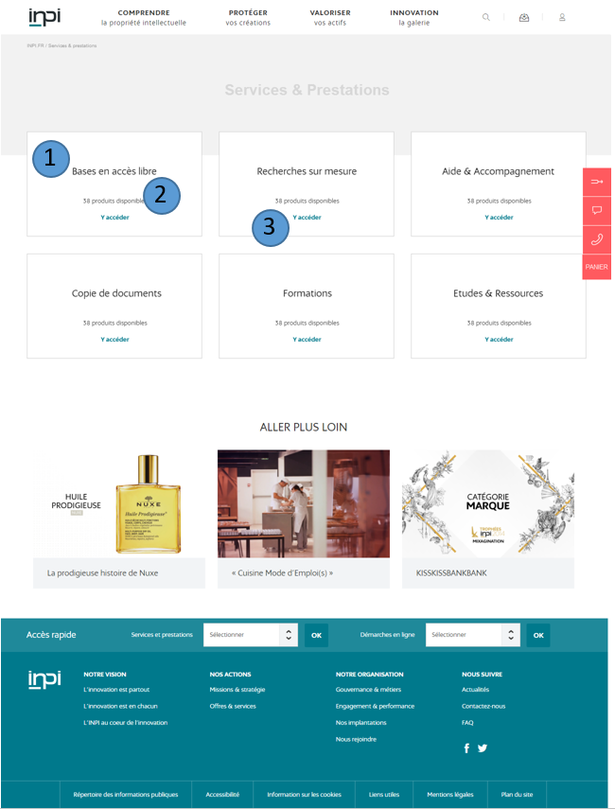

TABLET
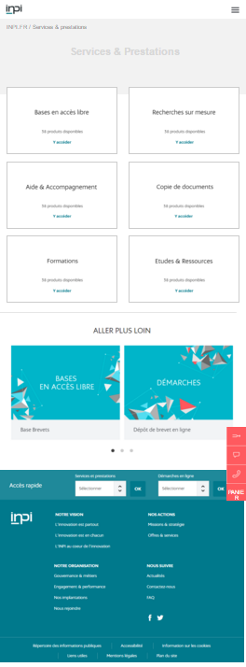

MOBILE

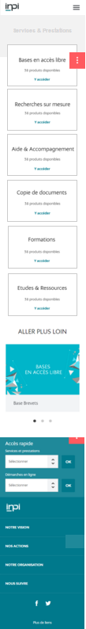

1.2 - Content
ZONED | NAME | FORMAT | RULE MANAGEMENT
1 | Title Category | H2 | RG1: Front-End Display Required  RG2: Legacy taxo / category S & P
2 | Many products available | Text | RG1: Front-End Display Required  RG2: Automatic Inheritance  RG3: Content Pack  RG4 If the number of products is greater than 0, then display the "N products available"
3 | CTA Access Page | Internal Link + Text | RG1: Front-End Display Required  RG2: Content Pack  RG3: The link should open in the same page

FOCUS STRIP SERVICES & AMENITIES
If the user is on the HP Services and benefits, while the headband is the same as at present production
If the user is on a page N-1 List, such base open access: The headband has a subtitle "open access basis" taxonomy inherited the name of the list

FOCUS MANAGEMENT FILTERS
On a list page by default all the list of the products in question are displayed.
When clicking on a filter, products strictly tagged by this filter will move up the list page.
If the user clicks a second filter, then tagged products for both filters will rise
When adding a filter, the tag back to top
The result counter is updated based on the operated filtering. The counters on the filters (right filters) will also be updated. If a filter does not contain an item, it will not be displayed.
This tag can be removed to click on the cross of suppression: the page will reload and the filter is removed in the results list page

FOCUS LABELS
When a label is created BO, it will take a unique ID, and two labels with the same name will be differentiated by this ID and will be different.
2 - LIST PAGE

2.1 - Wireframe

DESKTOP

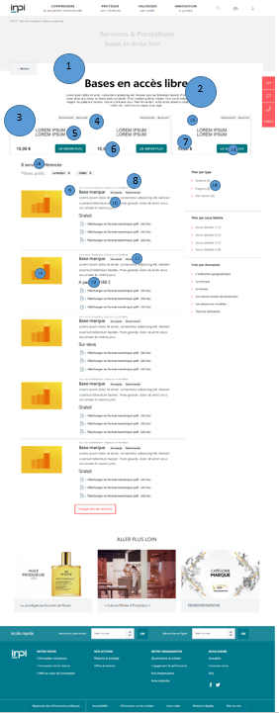

TABLET
Waiting wireframe Delphine
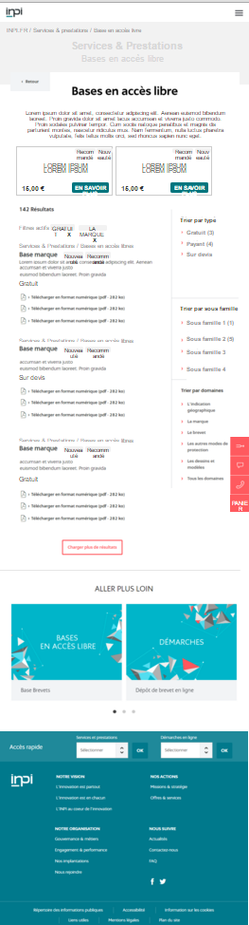
MOBILE

17
2.2 - Content
ZONED | NAME | FORMAT | RULE MANAGEMENT
1 | Name of product family | Maximum 70 alpha characters | RG1: Front-End Display Required  RG2: Inheritance Taxonomy
2 | short Description | 250 maximum alpha characters | RG1: Front-End Display Required  RG2: Legacy Expand  RG3: The block height adjusts to the size
3 | Lift leading products | 3 blocks | RG1: Display Front-End Non-Required  RG2: expand the Legacy S & P  RG3: The rise of 3 flagship products is not mandatory, it is no reassembled products, then display nothing  RG4: INPI can choose to display one or two products to rise, then only display the products
4 | Lift flagship products - Labels | 1 or 2 text fields | RG1: Display Front-End Non-Required  RG2: Legacy Product Datasheet  RG3: If only one label is entered in BO, then only display the corresponding label  RG4 If no label filled in BO then not show any  RG5: Labels do not have the same ID and may have the same name
5 | Lift flagship products - Product Name | Maximum 70 alpha characters | RG1: Front-End Display Required  RG2: Legacy Product Datasheet  RG3: If the product title exceeds a certain number of characters, then pass the title on several lines
6 | Lift flagship products - Product Price | text field | RG1: Front-End Display Required  RG2: Not editable in the BO if flow collection. Otherwise price com Edition soundtrack.  RG3: Cf Focus Price
7 | reinsurance prices | Text | RG1: price display reinsurance field if filled  RG2: reinsurance price: BO optional edition
8 | Breadcrumb | Text | RG1: Front-End Display Required  RG2: Not editable in the BO  RG3: The text is not clickable
9 | Product Name | Maximum 70 alpha characters | RG1: Front-End Display Required  RG2: Legacy Product Datasheet  RG3: On click, the user is redirected to the corresponding product page
10 | short Description | 250 maximum alpha characters | RG1: Front-End Display Required  RG2: Legacy Product Datasheet  RG1: On click, the user is redirected to the corresponding product page
11 | labels | text | RG1: Front-End Display Optional  RG2: Legacy Product Datasheet  RG3: If the mention RECOMMENDED OFFER NEW or is not specified in the product, then do not show the pictogram. If neither is entered, display nothing.
 | Price | Text | RG1: Front-End Display Required  RG2: Not editable in the BO if flow collection, otherwise editable com prize BO (see p20)  RG3: If the price of the product is free, then display the word "free"
13 | vignette | Image: 300 px by 200 px | RG1: Front-End Display Required  RG2: Legacy Product Datasheet  RG3: The display of the thumbnail is only on desktop  RG4 If the sticker is not given in BO, it does not leave a blank space on the list page and product texts occupy the entire width of the list column.  RG5: On click, the user is redirected to the corresponding product page
14 | Lift flagship products - CTA Read more | Text | RG1: On click on the CTA, the user is redirected to the corresponding product page
15 | Block lift flagship products | Zoned | RG1: At the click on the block, the user is redirected to the corresponding product page
16 | Number of products included in the list | Text | RG1: Content Pack  RG2: Change in the number of products based on selected filters  RG3: The default number of results is that of the class
17 | filter button | Text | RG1: On mobile only, the filter button is an anchor that will lead to the list of lowest filter on the page
18 | filter area | filters | RG1: See engine operation Production Research

FOCUS PRODUCTS CREATION
We have 2 types of prices:
- A guy who comes from the collection flows: not editable BO
- A type of price "COM" is editable BO

RG1: If there is no flow receipt for the product, then view the price com
RG2: If the product contains a choice between several offers while COM show the price of the product, and cause the flow collection for each offer.

Focus lift Featured Products
The rise of these flagship products will be through the creation of a specific Drupal view to the list page.
Lorsqu'INPI will add a product to rise, it will be automatically added to the expand the header.
The admin mode is defined in the tech specs.

Focus Display Count Products
Drupal will display 10 products on the List page.
A button "load more" clickable below these 10 products will allow charging 10 additional products in the same page.
Please note the wording of the button will validate the happy pack

3 - DATASHEET: ALL TYPES
3.1 - Wireframes

DESKTOP
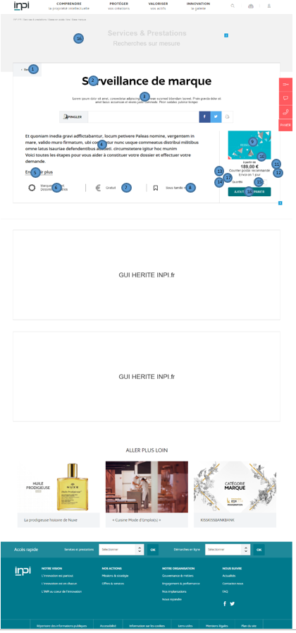

TABLET

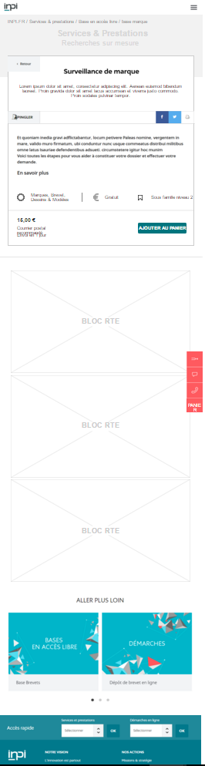
MOBILE

3.2Contenu
ZONED | NAME | FORMAT | RULE MANAGEMENT
1 | CTA Back | back button N-1 legacy INPI.fr | RG1: Front-End Display Required  RG2: content pack
2 | Product Name | Maximum 70 alpha characters | RG1: Front-End Display Required  RG2: editable in the BO
3 | Subtitle | 250 maximum alpha characters | RG1: Front-End Display No Mandatory  RG2: Legacy Product Datasheet
4 | short Description | 250 alphanumeric characters | RG1: Front-End Display Required  RG2: editable in the BO
5 | CTA Read more | Anchor that redirects to the class of the first block of the RTE page, it is an internal link | RG1: Front-End Display Required  RG2: Content Pack
6 | Field | Text + pictogram | RG1: Front-End Display Required  RG2: Edition BO  RG3: Ability to enter multiple domains for a single product  RG4: One pictogram will be displayed  RG5: One pictogram, and a 5 combined areas from the list of areas arranged
7 | Type of product | Text + pictogram | RG1: Front-End Display Required  RG2: Back Heritage Office
8 | Family Level 2 | Text + pictogram | RG1: Front-End Display No Mandatory  RG2: Text is inherited taxo  RG3: Picto Content Pack  RG4 If no last level 2, no pictogram or text displayed in forehead
9 | vignette | Image: 300px by 200px | RG1: Front-End Display optional  RG2: editable in the BO  RG3: If there is no sticker uploaded, no display in the forehead
10 | Reinsurance - Price | Text | RG1: Front-End Display Optional  RG2: editable in the BO  RG3: If there are no filled text, no display in the forehead
11 | Reinsurance - Delivery | Text | RG1: Front-End Display Optional  RG2: editable in the BO  RG3: If there are no filled text, no display in the forehead
12 | Price | Text | RG1: Front-End Display Required  RG2: Not editable in the BO if flow collection. Otherwise editable com prize BO
13 | Reinsurance Document Format | Text | RG1: Front-End Display Optional  RG2: editable in the BO  RG3: If there are no filled text, no display in the forehead
14 | Reinsurance Delivery Mode | Text | RG1: Front-End Display Optional  RG2: editable in the BO  RG3: If there are no filled text, no display in the forehead
15 | Amount | combo between 1 and 99 inclusive | RG1: Display Front-End Mandatory for the SKU product sheet Paying  RG2: Edition BO
16 | Cover Image | See picture focus behavior couv | See picture focus behavior couv
17 | Delivery delay | Text | RG1: Front-End Display mandatory  RG2: Legacy Product Datasheet
18 | CTA Add to Cart | different behavior depending on the SKU | RG1: If the SKU is a free product - CTA is a redirect link to an internal link if a link INPI ecosystem, if not open in a new tab if it is an external link.  RG2: If product with intelligence necessary parameters: see focus settings  RG3: If product specifications see focus quote  RG4: CTA Texts will be happy in the pack, different depending on the SKU
19 | Place settings | Viewing the contents of the parameters depending on the input BO | See Focus settings

FOCUS PARAMETERS

A product can have from 0 to N optional or required parameters (detailed list attached).
Each parameter corresponds to a dedicated screen.
A parameter can have a title, a subtitle, a tooltip, a field, a link, a review dedicated to a type field, a text by default, a double control specific entry and submission of form.
There is a special type for certain products, which may have several offers. In this case, the first parameter request screen is the choice between the offers available. Depending on the choice of the offer, the following parameters will be displayed and the price update.
Two types of navigation are available on each settings screen to return to the previous step without losing information previously entered or move to the next step. Or 1,2,3 ... button or the buttons "next" and "previous".
The last parameter, the next button is a button finish.
This button sending the form, adds it to your cart and displays a notification added to cart. This notification is made up of a text (content pack) and 2 buttons: "continue shopping" (content pack) that links to HP's S & P and "access to Cart (content pack) that return the cart page.

4 - FOCUS QUOTE
4.1 - wireframes

DESKTOP STEP 1

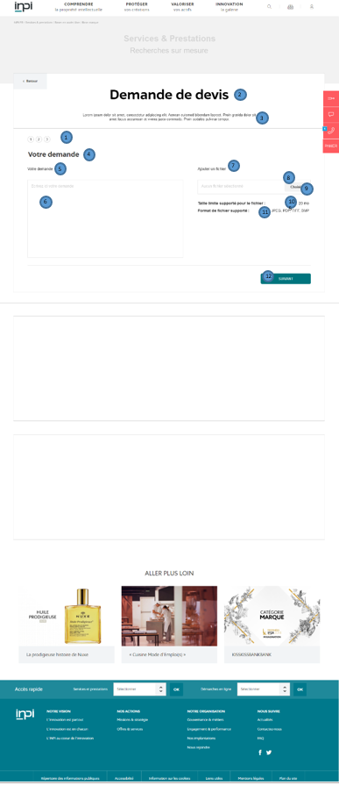

DESKTOP STEP 2

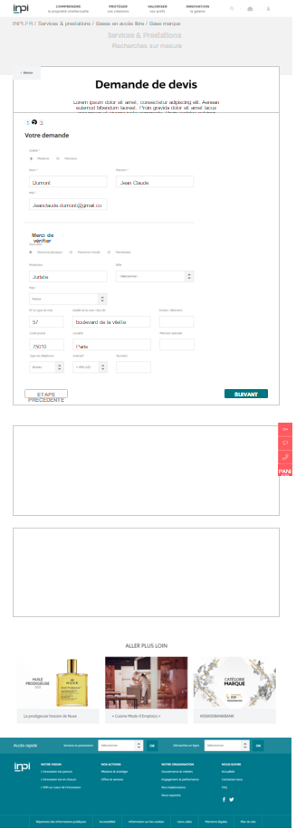

DESKTOP STEP 3
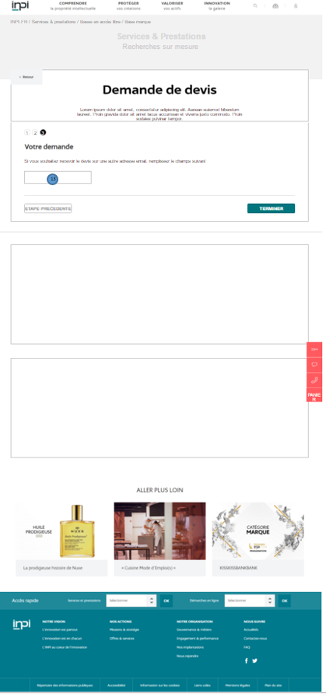
STEP 1 TABLET
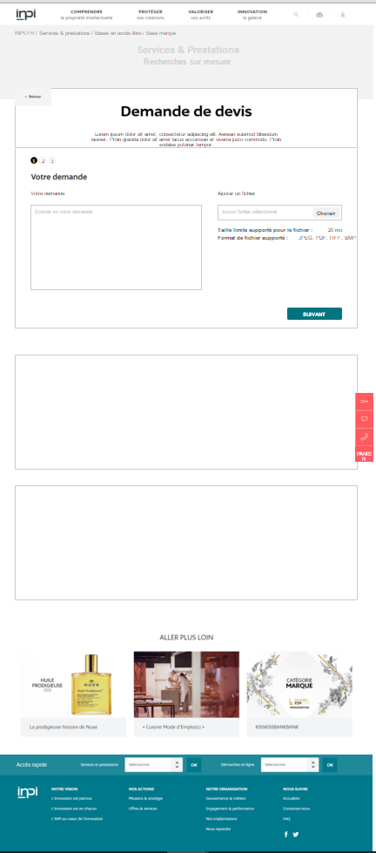
SHELF STEP 2
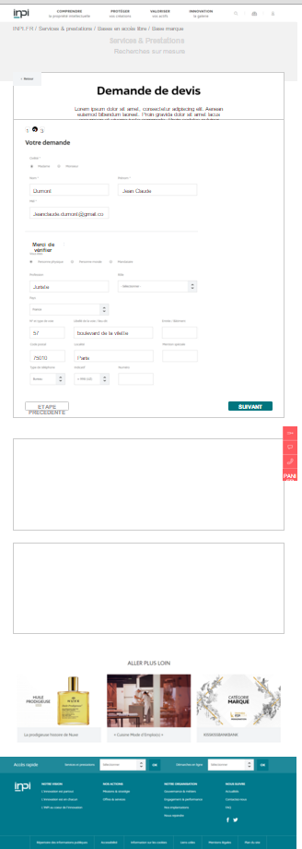
STEP 3 SHELF
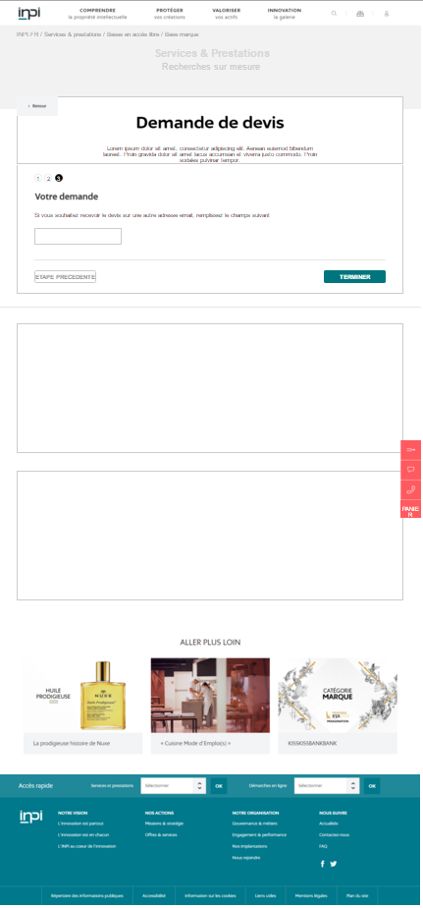

MOBILE - STEP 1

MOBILE - 2/3/4 STEPS

It lacks the PUSH APL and footer on step 2 mobile.
INPI wanted to display all the elements on a single wireframes, or it is very difficult if not impossible for any display, where size reduction imperfections screenshots after unzoom. The UX See online (see appendix UX) for the whole vision.
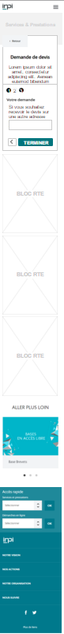
4.2 - CONTENT

ZONED | NAME | FORMAT | RULE MANAGEMENT
1 | Progress indication | Picture | RG1: Front-End Display Required  RG2: Displays the number of dynamic steps depending on the parameters chosen for the product  RG3: The buttons are not clickable  RG4: When clicking on the CTA "next" active state passes on the following image  RG5: a click on precedent, the active state goes to the previous frame.
2 | Product Name | Maximum 70 alpha characters | RG1: Front-End Display Required  RG2: Inherited-sheet
3 | Subtitle | 250 maximum alpha characters | RG1: Front-End Display Required  RG2: Inherited-sheet
4 | title | Text | RG1: Front-End Display Required  RG2: Content Pack
5 | wording your request | Text | RG1: Front-End Display Required  RG2: Content Pack
6 | text block | Text-area | RG1: Front-End Display Required  RG2: Content Pack
7 | Add a text file | Text | RG1: Front-End Display Required  RG2: content pack
8 | Block Document upload | Button that opens the box for file import dialog | RG1: Front-End Display Required  RG2: Content Pack
9 | Block document upload - this choice Bar | Text | RG1: Front-End Display Required  RG2: Content Pack
10 | Size limits for supported file | Text | RG1: Front-End Display Required  RG2: Content Pack
11 | Supported file format | Text | RG1: Front-End Display Required  RG2: Content Pack
12 | next CTA | Button | RG1: For each click on the button the user must get on the slide after if the required fields are filled  RG2: Content Pack
13 | CTA Previous step | Button | RG1: Front-End Display Required  RG2: Content Pack  RG3: On clicking the button above step, the user is redirected to the previous step with conservation of entered data to prefill the fields surfer
14 | reads another email address | Field Text + wording | RG1: Front-End Display Required  RG2: Content Pack  RG3: If the user filled this field, this is the address that will be used for e-mail exchanges with the shop. This address does not replace the address of the account inpi.fr .. This field is optional  RG4 Monitoring to make when submitting the form, the email address format and other fields of the form, recovery of existing  RG5: Displays an error text for the email address format: cf Content Pack

FOLLOWING STEPS
- On click on the CTA "request a quote" the user is redirected to the firing login / registration.
- At the end of identification the user is redirected to the first estimate of the input stage

2ND STEP
- The user enters the filling of the page request, via a text box
- It has the ability to add a file (size and weight to be defined) optionally at his request
- At the click Next, the user is redirected to step 3

STEP 3
- Resumption of the user account information
- All fields are pre-populated but modifiable.
- If the user uncheck the box "same billing address" fields in this section are emptied.
- At the click Next, the user is redirected to step 4

STEP 4
- Proposal for the user to enter a different email address than enter their profile, to receive quotes
- This field is pre-filled by default mail client.
- Warning: this address will not replace the main address of the user, but the destination address of the current quote
- The field is optional, if it is not filled, it is the address of the user profile that will be used
- On click on "finish" the quote is sent

5- PAGE CART

FOCUS CART
The cart will be kept for X days under the user's session through the installation of a cookie.
If the user clears cookies from their browser, then the cart will be deleted.

The basket is available at any time on the INPI ecosystem via the dedicated button on the remote control.
The remote control button is an internal link to the page Cart user.
If the user is logged in, then the page will be the connection after checkout
If the user is not connected, then the page will be the connection before checkout

When the shopping cart:
- no product will be present on the Cart page
- a text will be displayed (content pack)
A return button to the homepage S & P will be present (content pack)

5.1 - WIFRAMES

DESKTOP
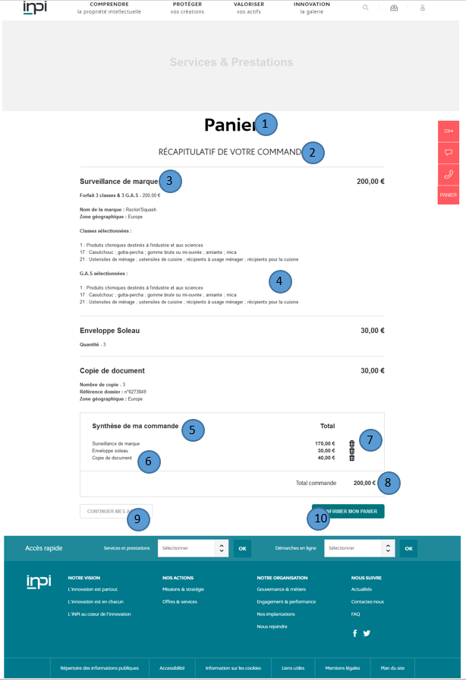

TABLET
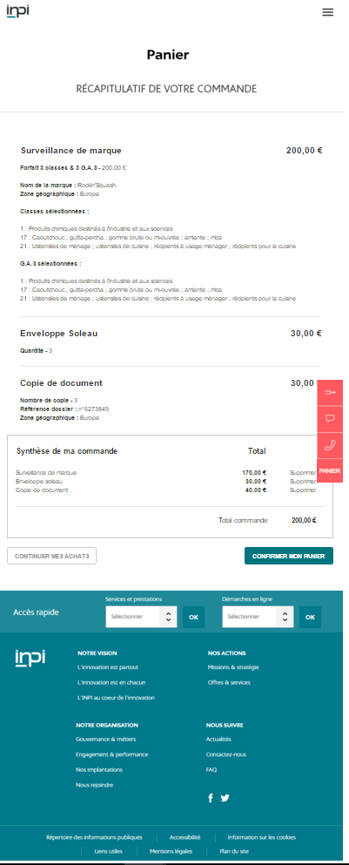

MOBILE
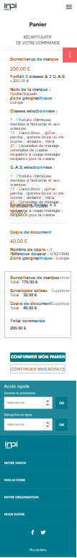

5.2 - WIFRAMES
ZONED | NAME | FORMAT | RULE MANAGEMENT
1 | Page title | Text | RG1: Front-End Display Required  RG2: Content Pack
2 | Subtitle Summary of your order | Text | RG1: Front-End Display Required  RG2: Content Pack
3 | Order Summary: Product title | Text | RG1: Front-End Display Required  RG2: Inherited sheet
4 | Order summary: Parameter Title | Text | RG1: Front-End Display Required  RG2: input parameters Legacy
5 | Summary of my order - Title | Text | RG1: Front-End Display Required  RG2: Content Pack
6 | Summary of my order - Product Name | Text | RG1: Front-End Display Required  RG2: input parameters Legacy
7 | Summary of my order - delete button | clickable button | RG1: Front-End Display Required  RG2: Not editable in the BO  RG3: When clicking on a delete button, the user's product will be removed from the basket after a page refresh  RG4: remove a product does not affect the status of other products of the basket them remains the same. The total is recalculated.  RG5: If delete a product that there is more material in the basket, show the basket in empty mode.
8 | total control | Text | RG1: Front-End Display Required  RG2: Content Pack  RG3: Total of all prices per line
9 | CTA - Continue in cats | internal link | RG1: Front-End Display Required  RG2: Content Pack  RG3: This link redirects to the HP Services & Facilities, keeping the contents of the Cart
10 | Confirm my cart | internal link | RG1: Front-End Display Required  RG2: Content Pack  RG3: This link redirects to the login page  RG4: When the button is clicked, the order (the order) is created in back office  RG5: No breadcrumb  RG6: The URL for the basket without login is kind / checkout (not def)
11 | Price per line | Text | RG1: Front-End Display Required  RG2: input parameters Legacy  RG3: This price represents the amount of the product multiplied by its unit price  RG4 If the product comes from a product with parameters (choice of the offer) then the unit price will be the price of the selected tender (cash inflows)
- 6 - REGISTRATION - CONNECTION
For all the fields on the registration form and connection refer to document DFS Consolidation INPI

6.1 - REGISTRATION
ZONED | NAME | FORMAT | RULE MANAGEMENT
1 | Descriptive text | RTE block | RG1: Front-End Display Required  RG2: Content Pack
2 | Retail reference below | Text | RG1: Front-End Display Required  RG2: Not editable in the BO

In the course of purchase or request a service, the user is logged in, must sign or is to create an account, they will be asked to have previously completed some specific information catalog services and benefits ( more personal information already filled by any person registering on the site).

Personal catalog information services and benefits are:

If natural person:
- Profession (required)
- Country (required)
- N ° path (required)
- Type and description of the way (required)
- Input / building (optional)
- Postal code (required)
- Town (required)
- BP / Locality (optional)
- Phone Type (required)
- Code (required)
- Phone Number (required)
- Add a number (optional)

If corporation:
- Corporate Name (required)
- Type of structure (required)
- Legal form (required)
- SIRET (required)
- Country (required)
- N ° path (optional)
- Type and description of the way (required)
- Input / building (optional)
- Postal code (required)
- Town (required)
- BP / Locality (optional)
- Phone Type (required)
- Code (required)
- Phone Number (required)
- Add a number (optional)

If agent:
- Corporate Name (required)
- Type of attorney (required)
- Legal form (required)
- SIRET (required)
- Country (required)
- N ° path (optional)
- Type and description of the way (required)
- Input / building (optional)
- Postal code (required)
- Town (required)
- BP / Locality (optional)
- Phone Type (required)
- Code (required)
- Phone Number (required)
- Add a number (optional)

6.1 - CONNECTION
For all the fields on the registration form and connection refer to document DFS Consolidation INPI
7 - MY ORDER

DESKTOP
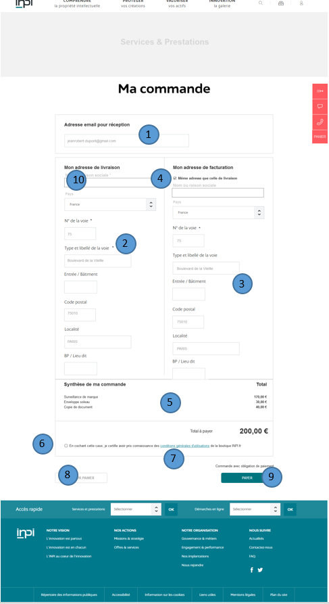

TABLET
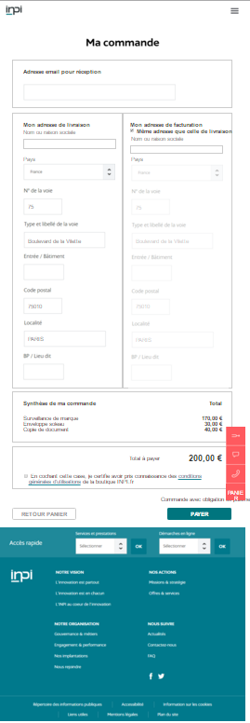

MOBILE
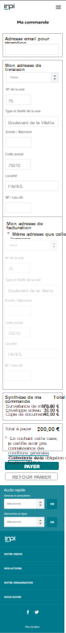

7.2 - Content
ZONED | NAME | FORMAT | RULE MANAGEMENT
1 | text field email address | text field + label | RG1: Front-End Display Required  RG2: Content Pack  RG3: The field is filled by default mail client account inpi.fr  RG4 If the user changes the address, this is the address that will be used for e-mail exchanges with the shop on this command. This address does not replace the address of the customer account inpi.fr.  RG5: mandatory field  RG6: The label will be defined in the happy pack  RG7: size mail Control (valid for all form fields (see inpi.fr))
2 | Champs delivery address | + Text text box | RG1: Front-End Display Required  RG2: Content Pack  RG3: These fields are pre-populated with the fields of the account inpi.fr. on the address fields, only the fields Country, channel label, postal code are mandatory. The others are optional.  RG4: mandatory address fields must be completed to advance to the next step.
3 | Champs billing address | + Text text box | RG1: Front-End Display Required  RG2: Content Pack  RG3: These fields are pre-populated with the fields of the account inpi.fr. on the address fields, only the fields Country, channel label, postal code are mandatory. The others are optional
4 | Checkbox same address delivery | Checkbox + text | RG1: Front-End Display Required  RG2: Content Pack  RG3: The checkbox must be pre-filled  RG4 If the user uncheck the box, then the following fields are displayed, unfilled  RG5: If the box is checked, billings fields are filled with the same values ​​as the delivery fields and they are not editable  RG6: mandatory address fields must be completed to take the next step
5 | Summary of my order | See page Cart | RG1: Front-End Display Required  RG2: Content Pack  RG3: Users can not remove one of his articles
6 | box  check TOS | Checkbox + text | RG1: Front-End Display Required  RG2: cotent pack  RG3: Check this box is mandatory to access the payment
7 | CTA to TOS | external link | RG1: Front-End Display Required  RG2: Content Pack  RG3: On clicking the link, the user is redirected to the page in the TOS target _blank
8 | CTA Cart back | internal link | RG1: Front-End Display Required  RG2: Content Pack  RG3: On clicking the link, the user is redirected to the Shopping Cart page
9 | CTA Pay | internal link | RG1: Front-End Display Required  RG2: Content Pack  RG3: On clicking the link, the user is redirected to the page of payment choice
10 | Name field / Social Reason | Text + Text Field | RG1: Front-End Display Required  RG2: Pre filled by legacy client account  RG3: editable field

8 - PAGE PAYMENT
- When clicking on "pay" the user will arrive on the page CHECKOUT REVIEW (payment page)
- This page include the same information as the CHECKOUT page but with the addition footer on the choice of payment method
- The user will have the choice of payment or payment by paybox account INPI.
- Paybox account will be imaged + button choose
- The INPI account will be represented by a login and password
- On click on the "confirm" button to define the happy pack, the user is redirected to the home page of the payment method chosen beforehand
Wireframe :
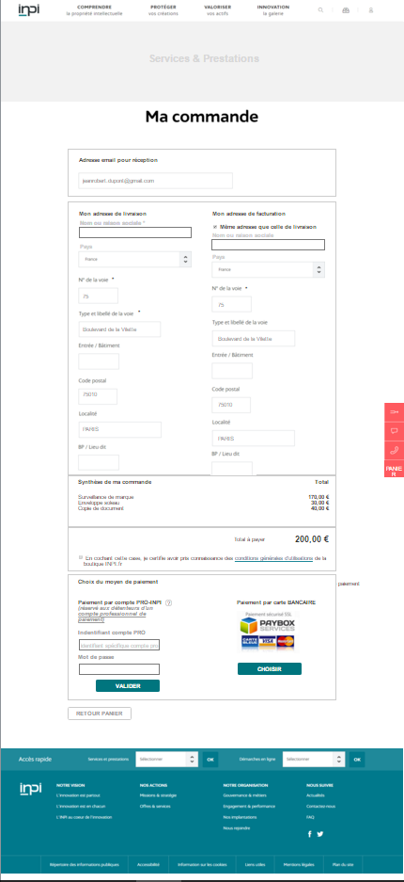

Tablet
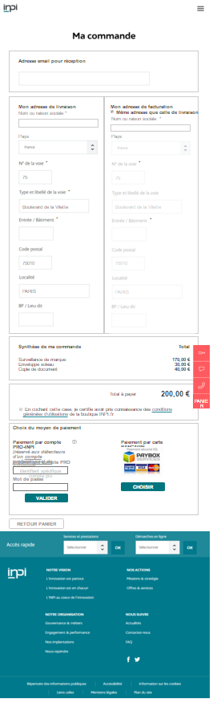

Mobile

9 - HOME PAGE PAYMENT ACCOUNT INPI
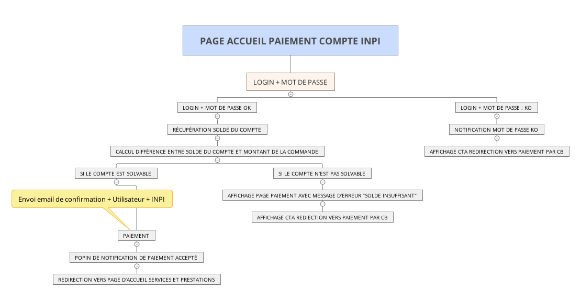

No mail invoice or payment confirmation. This is the collection that makes. We only have the order confirmation email

10 - HOME PAGE PAYMENT ACCOUNT CB Paybox
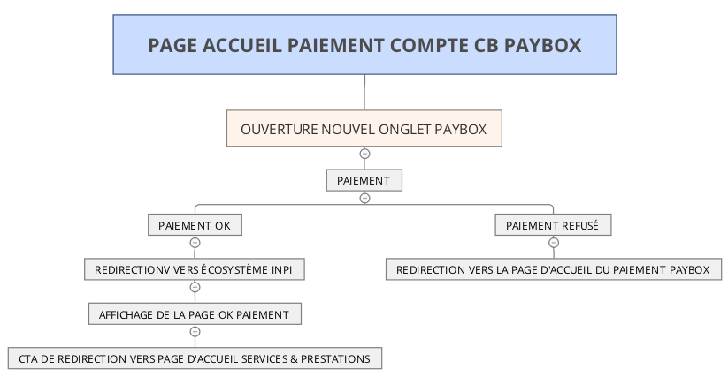
FOCUS MY WATCHES
Wireframe
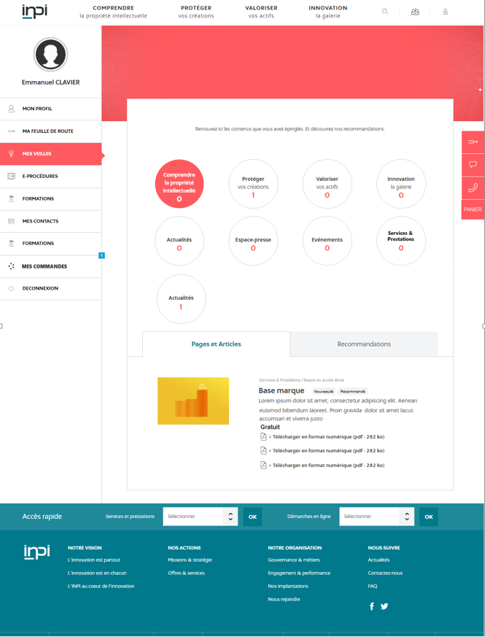

Operation of lifts:
When the pin of a product, 3 products in the same category (in order of publication desc) are set Recommendation (specified in the tech doc).

11 - PAGE HOME MY PROFILE - MY ORDERS
11.1 - WIREFRAME
DESKTOP

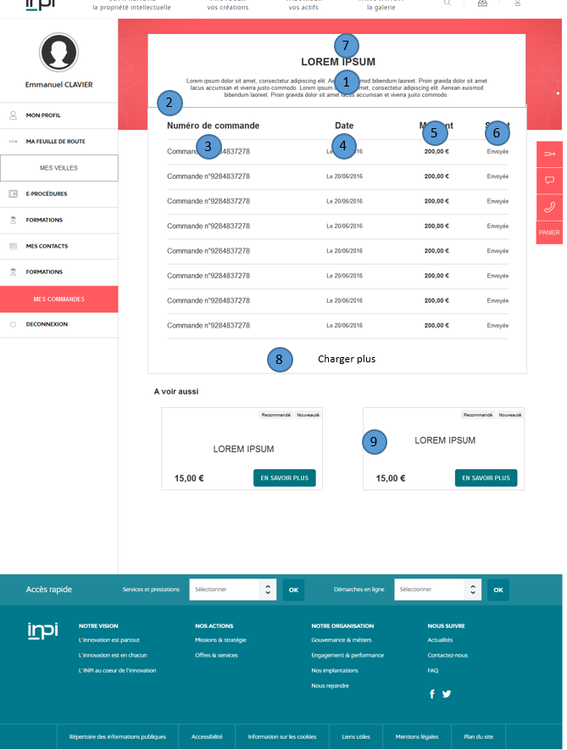

TABLET
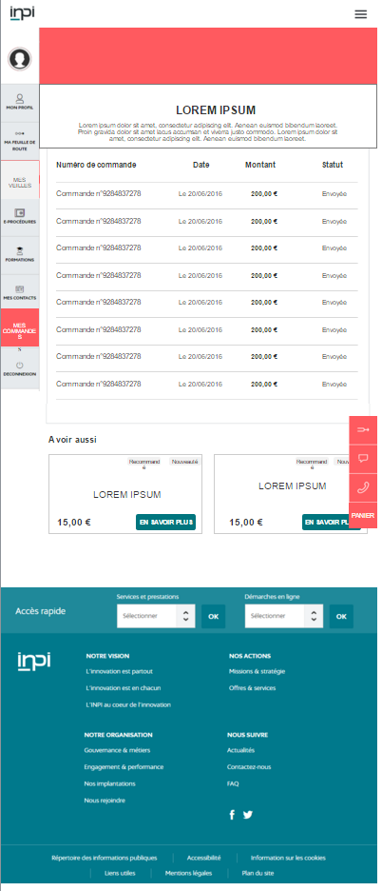
MOBILE
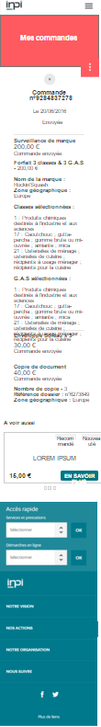

11.2 - BEHAVIOUR
ZONED | NAME | FORMAT | RULE MANAGEMENT
1 | Field Description Page Title + | Text | RG1: Front-End Display Required  RG2: Content Pack
2 | Table text fields | Text Field | RG1: Front-End Display Required  RG2: Content Pack  RG3: Sorting by columns asc / desc
3 | Text + control number | Text | RG1: Front-End Display Required  RG2: content pack + inherited control  RG3: On clicking the link, the user is redirected to the order detail page
4 | Field order date | + Text text box | RG1: Front-End Display Required  RG2: Content pack + inherited control (dates are still on the format DD / MM / YYYY)
5 | Champ amount of the order | Internal link | RG1: Front-End Display Required  RG2: control Inherited
6 | Field order status | Text | RG1: Front-End Display Required  RG2: Inherited order status  A3: There are 4 statuses: Awaiting Payment Processing // // // // Completed Application for Refund  RG4 If it is a unique product, the order status inherits the status of the product (see Focus laws)  RG5: If it is a multi product order, the order will go into complete when all products will be completed in status. If one product is "pending" or "being processed" or "assigned" the order will inherit that status.
7 | Page title | Text | RG1: Front-End Display Required  RG2: Content Pack
8 | load more | CTA | RG1: Display mandatory front-end if there are more than 10 commands displayed  RG2: On click, display 10 additional commands below the first ten
9 | push products | block | RG1: up to 3 possible block  RG2: automatic recovery following the same operation that lifts vigils, the first product of the last command.

12 - MY PROFILE PAGE - ORDER DETAILS
12.1 - WIREFRAME

DESKTOP

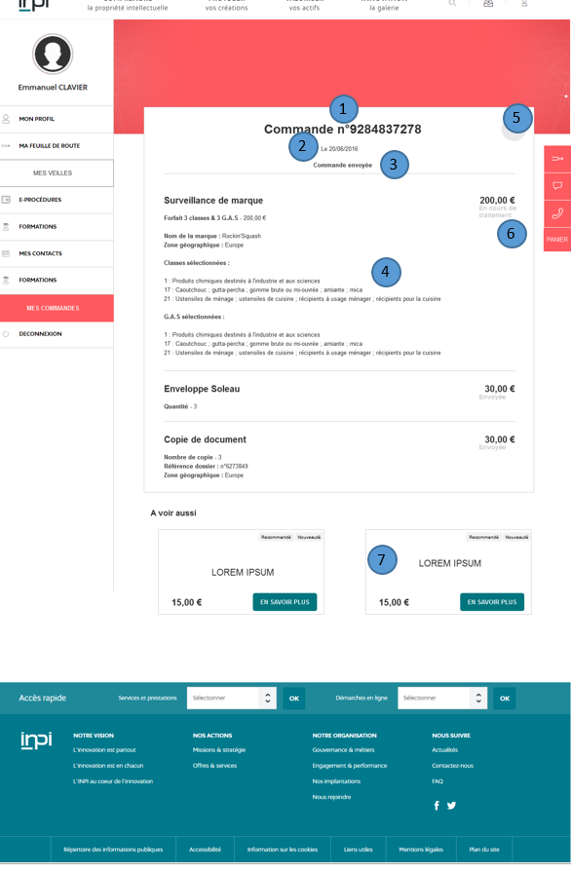

TABLET

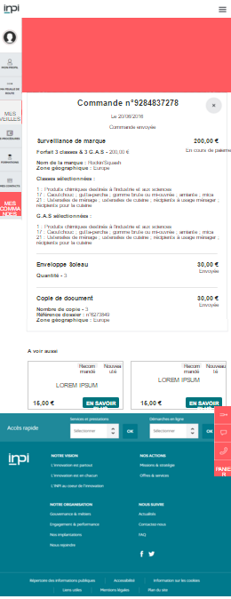

MOBILE

12.2 - BEHAVIOUR
ZONED | NAME | FORMAT | RULE MANAGEMENT
1 | control number field | Text | RG1: Front-End Display Required  RG2: control Inherited
2 | Order Date field | Text | RG1: Front-End Display Required  RG2: control Inherited
3 | order status field | Text | RG1: Front-End Display Required  RG2: Inherited order status  RG3: cf operation described on page 60
4 | Champs content control - see page Cart | Champs content control - see page Cart | Champs content control - see page Cart
5 | CTA closing cross | Internal link | RG1: Front-End Display Required  RG2: Not editable in the BO  RG3: At the click of the button, the user is redirected to the My Orders page
6 | product status | Text | RG1: Mandatory display  RG2: Legacy product status
7 | push service | block | RG1: up to 3 possible block  RG2: automatic recovery following the operation that lifts vigils, the first product of the last command.
13 - SEARCH ENGINE
ZONED | NAME | FORMAT | MANDATORY | TYPE | EXISTING ON INPI
1 | Product Name | Text | YES | FOREHEAD | NO
2 | vignette | Picture | NO | FOREHEAD | NO
3 | Short Description | Text | YES | FOREHEAD | NO
4 | Arbo S & P | Breadcrumb for each product, clickable | YES | FOREHEAD | NO
5 | GUIA - Download or paper | Internal link | NO | FOREHEAD | YES
6 | Result type - S & P | taxonomy | YES | FOREHEAD | NO

Recovery ecosystem search engine behavior INPI.fr

FOCUS ARTICLES
order statuses:
There are 4 statuses:
- Waiting for payment: initial automatic status to the creation of the order. This status lasts until the payment is not accepted.
- Processing: Automatic status after acceptance of the payment order
- Refund request: manual status BO for the manager to enable monitoring of the store.
- Finished: automatic status once all constituent products completed the order.

Statutes products:
There are 4 statuses
- Waiting for payment: inherited the status of the order
- Processing: If the payment was accepted
- rating: Manual managed BO
- Refund: inherited the status of the order
- Completed: Manual managed BO

BACK-OFFICE
1 - MANAGEMENT TABLE - N0 - VIEW OF ORDERS
The following table shows all the elements put together in the management table in back office.
RG1: This table will be accessible to managers and directors and INPI customer advisors
RG2: All columns are sortable in ascending and descending, except the complete detail column
ORDER NUMBER | ORDER DATE | STATUS | BUSINESS GROUPS | CUSTOMER NAME | MAIL CLIENT | FULL DETAIL
No. | Dd / mm / yyyy | status | BUSINESS group | CUSTOMER name | email | Link
RG3: the following filters may be applied to the view
- Date of the order
- Order number
- Order status
- Client name
- Mail Client
- business group
RG4: by default the "in process" filter is selected
RG5: filters are cumulative
RG6: filters should be able to deactivate the global vision for orders.

2 - MANAGEMENT TABLE - N-1 - PRODUCT VIEW
The following table shows all the elements put together in the management table in Back-Office, at the product level.
RG1: the default filter is on the Statute " Being processed "And" assigned ".
RG2: Each business group sees its products and managers, administrators and charged INPI customers see all the products.
RG3: The detail includes all the elements of the order and full details of the customer
RG4 Each column is sortable asc and desc except on full detail.
ORDER NUMBER | CUSTOMER NAME | STATUS | ORDER DATE | PRODUCT LABEL | COLLABORATEUR filling optional | FULL DETAIL summary order and customer details | No INTERNAL (filling optional)

RG5: This table can be filtered according to the following:
- Date of the order
- Order number
- Product Status
- customer name
- Label Products
- Groups trades
RG6: Each filter can be combined with other filters
RG7: filters should be able to deactivate the overall vision for the products.

3 - MANAGEMENT'S TABLE - N-1 - VIEW OF ESTIMATE
The following table shows all the elements put together in the management table in Back-Office, in quotes request.
RG1: Each business group sees its products and managers, and administrators in charge of INPI customers see all the products.
RG2: Each column is sortable by asc and desc except the full details.
CUSTOMER NAME | ORDER DATE | Product Name | DETAIL | No INTERNAL | COLLABORATER
RG3: This table can be filtered according to the following:
- Client name
- Date of the order
- Product Name
- business group
RG4: Each filter can be combined with other filters
RG5: filters should be able to deactivate the overall vision for the products.

4 - MANAGEMENT OF ROLES
CMS to four access levels for the part catalog services and benefits:

- Admin catalog INPI:
- To access all the controls Services catalog & benefits
- A access to all services ordered from the catalog of services & benefits
- Can perform all actions related to treatment benefits
- At the ability to add / edit / delete a product or service catalog with the exception of data from the collection service.
- Can perform all actions related to order processing
- Can make claims for reimbursement
- Have access to the store of statistics

- Store Manager:
- To access all the controls Services catalog & benefits
- To access all the products ordered from the catalog of services & benefits
- Can perform all actions related to order processing
- Can perform all processing products based share
- Can make claims for reimbursement
- Have access to the store of statistics

- The business team:
- To access all the products ordered from the catalog of services & benefits is concerned.
- Can perform all actions related to the processing of benefits attached to it (business group associated with benefits)
- Have access to the store of statistics

- Direct INPI customer consultant
- To access all the controls Services catalog & benefits (in playback mode)
- To access all the products ordered from the catalog of services & benefits in playback mode.

5 - STATISTICS
Access to statistics issued by the S & P catalog that must be paged over monthly periods, annual, daily, for a period.
- total sales
- CA / Product
- Total global sales
- Number of sales by product / services
- Number of Orders
- Number of orders out of time
- CA by means of payment
- means of a control amount
- of order processing times means
- Number of different status,
- Closing rate issued / abandoned / repaid
- By client (name surname country department)
- by client type (agent / natural person or legal person)
- by Product libel

6 - MAILS SENT BY THE SHOP

- Order Confirmation Mail:
content: the summary thereof + all the customer details.
To: Customer + cci: + boomaster to emails trades groups concerned with the ordered products.
when: after payment.

!!!: No Mail on payment: No mail confirmation of payment with invoice PDF attachment is to be expected. Sending the receipt of payment will be automatically Cashing.

- Mail to quote:
Content: with the summary of it + Full details of the customer
To: Customer + bcc: to boomaster and business group attached to the product
When: from the quote made.

- Mail order processed:
Contents: a satisfaction form (available only in online mode with the ability to link to an order)
To: Client
When: when the order is placed in status "completed" for 7 days.

7 - MAIL ALERT

- Mail alerts on order processing time
Content: content pack + dynamic text (No. Control)
Who: boomaster
When: The most important time of the ordered products is exceeded and the order status is still "in process".

- warning messages on product processing times
Content: content pack + dynamic text (No. Control + product name)
Who: + email boomaster business group responsible for the delivery
When: delay of delivery is exceeded and the status is always "in process" be "assigned"

- Email alert on technical payment problem
Content: content pack + dynamic (No. Control)
To: boomaster + admin
When: on payment exceeded recovery time (time set in tech doc)

- Email alert on problem collecting data retrieval or updating of prices.
Content: content pack + dynamic
To: admin
When, if not recovery detection rates.

- Email alert about problems in the stream sent to collection. (To be defined in tech doc)
Content: content pack + dynamic
To: admin
When: refused the payment.

8 - PARAMETERS
The list of parameters is detailed in the annex.
The operation will be described in the BO tech doc.
10 - FIELDS EXPORT
The list of fields is detailed in the annex.

